**Chapter 4**

**Analysis And Design**

**4.1 Introduction**

This chapter presents the analysis and design phase of the project, detailing how the functional and non-functional requirements were interpreted and structured into use cases, user stories, and an overview of the planned design components such as use case diagrams, sequence diagrams, and class diagrams. The system is being developed using Agile methodology, and this chapter is organized by sprint. Each sprint represents a set of related features implemented during a particular development cycle. In addition to the core sprints, an enhancement sprint (Sprint 4) is included to improve system efficiency and scalability .This sprint is planned to be implemented if time permits, and is aimed at reducing citizen workload and improving inter-ministry coordination.

**4.2 Analysis**

This section outlines the detailed functional requirements and user interactions for each sprint. It includes use case descriptions, user stories, and analysis of system behavior based on user roles and expected functionalities.

**Main stakeholder :**

1. **Citizens :** Individuals who use the platform to access government services, interact with institutions, and communicate with others.
2. **Government Institutions :** Official entities that publish posts and announcements and receive citizen feedback.
3. **Government Employees:** Authorized staff who represent institutions and support their operations.

**4.2.1 Sprint 1: User Authentication System**

This sprint focuses on implementing secure registration and login ,password recovery, and account verification functionality for citizens, government institutes, and government employees.

**4.2.1.1 Functional Requirements**

* User should be able to select type to register
* User should be able to register with personal or institutional information
* User should be able to verify their email using a verification code.
* User should be able to log in using national ID and password after verification.
* User should be able to reset password using their registered email
* User should be able to change password
* The system should be able to register users (citizen, employee, or institute) with different required fields.
* System should be able to send email verification code upon registration.
* System should be able to activate/deactivate accounts if needed
* System should be able to allow login only for active accounts
* System should be able to prevent login via national ID and password.
* System should be able to prevent login if email is not verified
* System should be able to allow forgotten password workflow through email with reset link.
* System should be able to encrypt and store passwords securely
* System should be able to validate duplicate national IDs with type or email entries across user types.

**4.2.1.2 Use Case Descriptions**

Covers detailed description about use cases

|  |  |
| --- | --- |
| UC-01 | Register New User |
| Actors | Citizen, Government Institute Representative, Government Employee |
| Preconditions | User does not have an existing account |
| Main Flow | 1. System displays user type selection screen  2. User selects type (citizen/institute/employee)  3. System displays appropriate registration form  4. User completes form and submits  5. System validates data and sends SMS verification code  6. User enters received code  7. System verifies code and creates account  8. System displays success message |
| Alternative Flows | -Invalid data: System displays error messages  - Verification timeout: System allows resend of code  - Existing user: System informs user account exists |
| Postconditions | User account created and verified. |

|  |  |
| --- | --- |
| UC-02 | User Login |
| Actors | All registered users |
| Preconditions | User has a registered account |
| Main Flow | 1. System displays initial login screen (ID + user type)  2. User enters credentials  3. System validates and displays password screen  4. User enters password  5. System authenticates and grants access  6. System displays appropriate dashboard |
| Alternative Flows | * Invalid credentials: System displays error * Forgotten password: User initiates password recovery |
| Postconditions | User logged in. |

|  |  |
| --- | --- |
| UC-03 | Password Recovery |
| Actors | All registered users |
| Preconditions | Users are authenticated  User has registered email address |
| Main Flow | 1. User selects "Forgot Password"  2. System prompts for ID and user type  3. User provides information  4. System sends email verification code  5. User enters code  6. System verifies and allows password reset  7. User enters new password  8. System confirms password change |
| Postconditions | Password updated. |

|  |  |
| --- | --- |
| UC-04 | Change Password |
| Actor | All registered users |
| Precondition | Users are authenticated |
| Main Scenario | 1. Users goes to change password 2. Enters current + new password 3. system updates |
| Alternative Scenario | * Wrong current password |
| Postcondition | Password updated |

**4.2.1.3 User Stories**

**Covers all the authentication-related user goals and expectations.**

1. As a new user, I want to select my user type (citizen, government institute, or government employee) so that I can register with the appropriate form.
2. As a citizen, I want to input my personal details (name, ID, mobile number, etc.) so I can create an account to access government services.
3. As a government institute representative, I want to input our institute details (institution name, registration number, authorized representative details) so we can register our organization.
4. As a government employee, I want to input my employee details (employee ID, department, position) along with personal details so I can register for system access.
5. As a user registering for the system, I want to receive and enter a verification code sent to my email address so my account can be activated securely.
6. As a registered user, I want to first enter my ID and user type, then be prompted for my password so I can securely access my account.
7. As a user who forgot my password, I want to request a password reset via email verification so I can regain access to my account.
8. As a logged-in user, I want to change my password after successful login so I can maintain account security.

**4.2.2 Sprint 2: End-to-End Citizen-Institute Engagement**

This sprint focuses on implementing full interaction capabilities between the citizen and the platform. It enables the citizen to engage with government institutes, submit service requests, complaints, view announcements, manage social features like friendships and messaging, and receive notifications. It also introduces management capabilities for institutes regarding announcements, service requests, and complaints, allowing smoother citizen–institute communication.

**4.2.2.1 Functional Requirements**

* Citizen should be able to view and update their profile (photo, name, address, etc.
* Citizen should be able to add/edit connected social profiles (Facebook, Instagram, WhatsApp)
* Citizen should be able to search for other citizens
* Citizen should be able to send and accept friend requestt
* Citizen should be able to view a list of friends
* Citizen should be able to unfriend an existing friend
* Citizen should be able to message friends
* Citizen should be able to follow/unfollow a government institute
* Citizen should be able to view a list of followed institute.
* Citizen should be able to view announcements published by followed institutes
* Citizen should be able to open and read full content of each announcement
* Citizen should be able to make like and comment on announcements
* Citizen should be able to view a list of followed institutes, filtered by their region
* Citizen should be able to select a service type for the chosen institute
* Citizen should be able to submit a service request /complaint by writing a description and selecting a date
* Citizen should be able to view a list of submitted requests /complaints with status: (Pending, Completed, Rejected)
* Citizen should be able to view a list of government-related bills (electricity, water, taxes, etc.)Each bill shows: type, government entity, amount, due date, status (Paid/Unpaid)
* Citizen should be able to click “Pay Now” for unpaid bill
* Citizen should receive notifications related to actions like:

1. Request status is updated
2. A friend request is accepted
3. A new announcement is published by a followed institute
4. A new pill has to paied

* Institute should be able to approve or reject announcements created by employees
* Institute should be able to publish approved announcements
* Government Institute should be able to view list of announcements created by employees
* Institute should be able to edit or delete published announcements
* Institute should be able to add service types or bill type related to its functions
* Institute should be able to assign employees to each service type and bill type
* Institute should be able to edit or delete service types or bill type
* Institute should be able to view incoming service requests and complaints, filtered by status
* Institute should be able to assign employees to handle specific requests or complaints
* Institute should receives notifications related to actions like:

1. A new service request or complaint is submitted
2. A citizen follows their profile
3. An employee creates an announcement

* System should be able to allow citizens to edit their profile information.
* System should be able to allow uploading of profile pictures.
* System should be able to store and validate profile updates.
* System should be able to generate a personalized feed for citizens.
* System should be able to deliver posts to the dashboards of followers.
* System should be able to allow likes and comments on posts.
* System should be able to allow citizens to send friend requests.
* System should be able to allow users to accept or reject friend requests.
* System should be able to update friendship status accordingly.
* System should be able to list accepted friends for each citizen.
* System should be able to allow citizens to unfriend others.
* System should be able to send notifications for citizens and institute according to action
* System should be able to allow citizens to follow/unfollow government institutes..
* System should be able to allow institutes to publish posts.
* System should allow users to mark notifications as read.
* System should be able to show unread and recent notifications.

**4.2.2.2 Use Case Descriptions**

|  |  |
| --- | --- |
| UC-01 | Submit Service Request |
| Actor | Citizen |
| Preconditions | Citizen must be logged in and must follow at least one institute. |
| Main Flow | 1. Citizen navigates to service request form  2. Chooses institute and service type  3. Enters request details  4. Submits the request |
| Postconditions | Service request is saved and assigned a "Pending" status; notification is sent to the institute. |

|  |  |
| --- | --- |
| UC-02 | Manage Announcement |
| Actor | Institute Admin |
| Preconditions | Announcement must be created by an employee. |
| Main Flow | 1.Admin views pending announcements  2. Approves or rejects  3. Publishes announcement  4.Edit or delete announcement after posted |
| Postconditions | Approved announcements are visible to followers rejected ones are discarded |
| Exceptions | No pending announcements Unauthorized access attempt |

|  |  |
| --- | --- |
| UC-03 | Add Complaint |
| Actor | Citizen |
| Preconditions | Must be logged in and must follow the institute. |
| Main Flow | 1. Citizen chooses an institute  2. Fills in complaint form  3. Submits complaint |
| Postconditions | Complaint is saved and assigned a "Pending" status; notification sent to institute. |

|  |  |
| --- | --- |
| UC-04 | Pay Bill |
| Actor | Citizen |
| Precondition | Citizen must be logged in. |
| Main Flow | 1. Citizen navigates to Bills & Payments tab.  2. System displays list of bills with status.  3. Citizen clicks on “Pay Now” for an unpaid bill.  4. System processes the payment.  5. System updates bill status to “Paid” |
| Alternative Flow | * If the bill is already marked as "Paid", the "Pay Now" button is disabled. |
| Postconditions | The bill status is updated, and the payment is recorded. |

|  |  |
| --- | --- |
| UC-05 | Add/Edit Connected Profiles |
| Actor | Citizen |
| Precondition | Citizen is authenticated |
| Main Scenario | 1. Citizen opens connected profiles tab 2. Add/edits 3. Submit and confirm 4. system saves |
| Alternative Flow | * System rejects invalid URLs |
| Postcondition | Connected profile updated |

|  |  |
| --- | --- |
| UC-06 | View friends list |
| Actor | Citizen |
| Precondition | Citizen is authenticated |
| Main Scenario | 1. clicks friends tab 2. system shows list of friends |
| Alternative Flow | * No friends * show empty message |
| Postcondition | Friends list displayed |

|  |  |
| --- | --- |
| UC-07 | Manage Service request/bill/complaints |
| Actor | Institute Admin |
| Preconditions | Institute is authenticated. |
| Main Flow | 1.Admin of institute add service types or bill type for each institute function  2. Admin assign list of employee to this type of service or bill  3. Admin assign specific employee to specific incoming request or complaints  4.System notify employee which assigned |
| Postconditions | Each type of service or bills have list of employee  Each service request or complaint is handeled by specific employee |

**4.2.2.3 User Stories**

1. As a citizen I want to update my profile so that my personal info is accurate
2. As a citizen I want to connect my social accounts so people can reach me easily
3. As a citizen I want to add/remove friends so I can build a social network
4. As a citizen I want to message my friends so I can communicate privately
5. As a citizen I want to follow/unfollow institutes so I can stay updated
6. As a citizen I want to view announcements so I stay informed about government news
7. As a citizen I want to make like and comment on announcements so I can express and interact
8. As a citizen I want to submit service requests so I can request help from institutions
9. As a citizen I want to track my requests so I know the status of my servic
10. As a citizen I want to submit complaints so I can report problems
11. As a citizen I want to get notifications so I stay updated about activities
12. As a citizen I want to view my bills and pay them easily so that I can manage and settle my obligations with government institutions efficiently
13. As a Government Institute, I want to approve or reject announcements submitted by employees so that only appropriate content is published.
14. As a Government Institute, I want to publish approved announcements to keep citizens informed.
15. As an Institute I assign employees to requests so I can respond to citizens efficiently
16. As an Institute I handle complaints so I can solve it and address public concerns
17. As an Institute I get notifications so I can respond quickly to actions

**4.2.3 Sprint 3: Institute & Employee Functional Completion**

This sprint finalizes profile management for government institutes and employees, ensuring control over announcements, service handling, and communication.

**4.2.3.1 Functional Requirements**

* Government Institute should be able to
* Government Institute should be able to view Institute Dashboard with total number of: Employees , Followers , Service Requests (by status) ,Complaints (by status) ,Announcements (by status)
* Government Institute should be able to view and edit institute profile info (logo, name, address)
* Government Institute should be able to add/edit connected links (Facebook, Website)
* Government Institute should be able to view a list of followers (citizens who followed the institute
* Government Employee should be able to view and update their profile (photo, contact info)
* Government Employee should be able to create new announcement and submit it to institute for approval
* Government Employee should be able to view details of assigned service requests or complaints
* Government Employee should be able to change status for assigned service requests or complaints
* Government Employee should be able to assigne bill to specific citizen

**4.2.3.2 Use Case Description**

|  |  |
| --- | --- |
| UC-01 | View Institute Dashboard |
| Actor | Government Institute |
| Precondition | Institute is authenticated |
| Main Scenario | 1. Institute logs in 2. navigates to dashboard 3. System fetches & shows data |
| Alternative Flow | * System returns error if data fetch fails |
| Postcondition | Dashboard data shown |

|  |  |
| --- | --- |
| UC-02 | Edit Profile |
| Actor | Government Institute and Government Employee |
| Precondition | Institute and employee are authenticated |
| Main Scenario | 1. Institute and employee navigates to profile 2. edits fields 3. submits 4. system saves changes |
| Alternative Flow | * Validation fails (e.g., invalid link) |
| Postcondition | Profile updated |

|  |  |
| --- | --- |
| UC-03 | Add/Edit Connected Profiles |
| Actor | Government Institute |
| Precondition | Institute is authenticated |
| Main Scenario | 1. Institute opens connected profiles tab 2. Add/edits 3. Submit and confirm 4. system saves |
| Alternative Flow | * System rejects invalid URLs |
| Postcondition | Connected profile updated |

|  |  |
| --- | --- |
| UC-04 | View Followers |
| Actor | Government Institute |
| Precondition | Institute is authenticated |
| Main Scenario | 1. clicks followers tab 2. system shows list of followers |
| Alternative Flow | * No followers * show empty message |
| Postcondition | Followers list displayed |

|  |  |
| --- | --- |
| UC-05 | Create Announcement |
| Actor | Government Employee |
| Precondition | Employee is authenticated |
| Main Scenario | 1. Employee fills announcement form 2. submits 3. system stores with status “pending” |
| Postcondition | Announcement created in pending status |

|  |  |
| --- | --- |
| UC-06 | Edit/Delete Pending Announcement |
| Actor | Government Employee |
| Precondition | Employee is authenticated  Announcement still pending |
| Main Scenario | 1. Employee edits/deletes 2. system verifies status 3. updates or deletes |
| Postcondition | Announcement updated or deleted |

|  |  |
| --- | --- |
| UC-07 | View Assigned Service Requests /Complaint |
| Actor | Government Employee |
| Precondition | Employee is authenticated  Institute Assigned employee to service requests or complaints |
| Main Scenario | 1. Employee opens Assigned request or complaints tab 2. views filtered list by status |
| Postcondition | Assigned Requests or complaints list appear |

|  |  |
| --- | --- |
| UC-08 | Update Request or Complaint Status |
| Actor | Government Employee |
| Precondition | Employee is authenticated  Employees assigned to service requests or complaints |
| Main Scenario | 1. Employee opens assigned service requests or complaints tab 2. selects Specific requests or complaints 3. View requests or complaints details to solve 4. Change status |
| Postcondition | Service requests or complaints status are updated |

**4.2.3.3 User stories**

1. As a Government Institute, I want to view a summary dashboard of service requests, employees, complaints, and announcements so that I can monitor platform activity.
2. As a Government Institute, I want t o edit my profile and add connected links (e.g., website, WhatsApp) to keep my contact information current.
3. As a Government Institute, I want to view the list of citizens following my profile to understand engagement.
4. As a Government Employee, I want to create announcements and submit them for institute approval so that I can contribute updates or news.
5. As a Government Employee, I want to edit or delete pending announcements that haven’t been approved yet in case of mistakes before approval.
6. As a Government Employee, I want to view the service requests and complaints assigned to me so that I can follow up efficiently
7. As a Government Employee, I want to update the status of assigned service requests and complaints to reflect progress.
8. As a Government Employee, I want to edit my personal profile to keep my contact and personal info updated.
9. As a Government Employee, I want to send bill to citizen so he can pay easily with local payment tools in Gaza.

**4.2.4 Sprint 4: Institutional Communication and Admin Panel (Future Enhancement )**

This sprint is proposed as an **enhancement** to improve institutional coordination and streamline document issuance. **It will be implemented only if time permit.**

This sprint enables direct **communication between government institutions** .In many governmental workflows, services often depend on coordinated actions between multiple institutions. Traditionally, these interactions are manual, slow, and require the citizen to physically carry documents between ministries, which leads to inefficiency, delays, and frustration , especially in high pressure environments.Also, add an **Admin Panel** to manage users, institutions, and platform health.

Real World Example :

For instance, rather than requiring a citizen to collect a birth notification from the health authority and deliver it to the interior ministry for a birth certificate, the health institution could send this request directly to the interior ministry within the platform. This simplifies the process for both government staff and citizens

**4.2.4.1 Functional Requirements**

* Government Institute Should be able to send structured service requests to other government institutions (e.g., birth registration → Interior Ministry).
* Government Institute should be able to receive and process requests from other institutions.
* Government Institute should be able to track sent requests with status ("pending", "accepted", "rejected").
* Government Institute should be able to send status updates or responses to requests.
* Government Institute should be able to view an Inbox and Outbox for requests.
* Government Employee should be able to log in and act on behalf of their institution.
* Government Employee should able to draft and send official service requests.
* Government Employee should be able to update the status of incoming requests.
* Government Employees should be able to view list of sent/received requests.
* Admin should be able to log in securely as a superuser.
* Admin should be able to create/edit/suspend users and institutions.
* Admin should be able to approve or deny new institution registration requests.
* Admin should be able to monitor inter-ministry communication logs.
* Admin should be able to view and export platform analytics (e.g., most requested services, number of users, etc.).
* Citizen should be able to view status of automated requests (e.g., birth certificate).
* Citizen should be able to receive a notification when a certificate is ready.
* Citizen should be able to download the certificate from the dashboard once issued.
* System should be able to send structured requests between institutions (with status tracking).
* System should be able to log and archive all inter-institutional communications.
* System should be able to notify relevant users (e.g., citizen or receiving institution) on request status change.
* System should be able to manage and display institution inbox/outbox.
* System should be able to assign and verify institution roles and permissions.
* System should be able to allow admins to manage users and institutions.
* System should be able to generate usage reports for the admin dashboard.

**4.2.4.2 Use Case Descriptions**

|  |  |
| --- | --- |
| UC-01 | Send Institutional Request |
| Actor | Government Employee for sender institute |
| Precondition | Employee is authenticated |
| Main Scenario | 1. Employee fills out request form according to request type. 2. Sends it to another institute |
| Alternate Flow | * Request rejected due to validation issues * Notify sender |
| Postcondition | Request appears in the recever institute's inbox |

|  |  |
| --- | --- |
| UC-02 | Received Institutional Request |
| Actor | Government Employee for recever institute |
| Precondition | Employee is authenticated,Request available in inbox |
| Main Scenario | 1. Employee opens request 2. Reviews 3. Accepts or Rejects |
| Alternate Flow | * Request rejected due to validation issues * Notify sender |
| Postcondition | Citizen receives update |

|  |  |
| --- | --- |
| UC-03 | Manage Platform |
| Actor | Admin |
| Precondition | Logged in as admin |
| Main Scenario | Views users, institutions, requests, reports → takes action |
| Postcondition | Changes applied system-wide |

**4.2.4.3 User Stories**

1. As a government institute, I want to send official service requests to other ministries (e.g., birth notification), so the process can be handled automatically.
2. As a government institute ,I want to view received requests in an inbox, so I can process them accordingly.
3. As a government institute ,I want to track the status of outgoing requests, so I can ensure they are processed.
4. As an admin, I want to manage users and institutions, so I can ensure system compliance and correct usage.
5. As an admin, I want to view all inter-institutional requests, so I can monitor platform interactions.
6. As an admin, I want to see system usage statistics, so I can assess platform effectiveness.
7. As an admin, I want to approve/reject new government institutions, so only verified ministries access the system.
8. As a citizen, I want to receive notifications when a certificate is issued, so I don’t have to check manually or move between ministries.

**4.2.5** **Non Functional Requirements**

* **Performance:** The system should support up to 10,000 concurrent users without performance degradation.
* **Scalability:** The system should be scalable to support future additions like new institutions or services.
* **Availability:** The system should be available 24/7 with a downtime of less than 1% per year.
* **Security :** All user data and communication must be encrypted using HTTPS and SSL.
* **Authentication:** Secure login via national ID and password and email verification is required.
* **Maintainability:** The system codebase should follow Laravel standards and be modular for easy maintenance.
* **Responsiveness:** Pages and actions should respond within 2 seconds under normal network conditions.
* **Backup and Recovery**: The system should have daily automated backups with a recovery time objective under 30 minutes.
* **Auditability**: Admin should be able to view logs of actions performed by any institution.
* **Usability:** The interface must follow user-friendly UI/UX guidelines, and be easy to use even for non-technical users.
* **Browser Support:** Compatible with Chrome, Firefox, and Edge (latest two versions).
* **Mobile Support** : The platform should be responsive and mobile-friendly.

**4.3 Design**

This section presents the visual and architectural design elements used to implement the described functionalities. These designs support developers in understanding the structure, behavior, and interactions of system components.

**This section includes diagrams for each sprint such as:**

* **Use Case Diagrams :** To visualize interactions between actors and system features across each sprints.
* **Sequence Diagrams:** To demonstrate the dynamic behavior and message flow between objects for core use cases .
* **Class Diagrams:** To represent the main system entities and their relationships.
  + 1. **Sprint 1 diagrams**

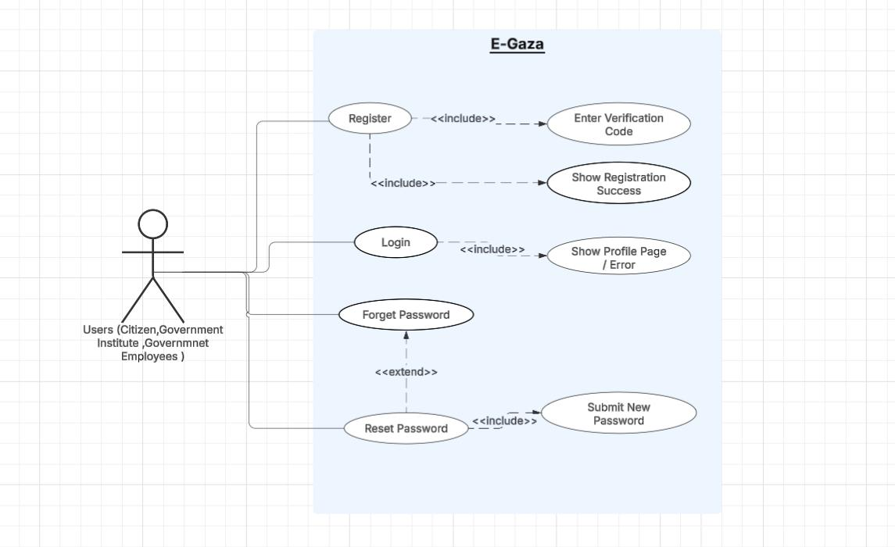

Figure 1: Use Case Digram For Sprint 1

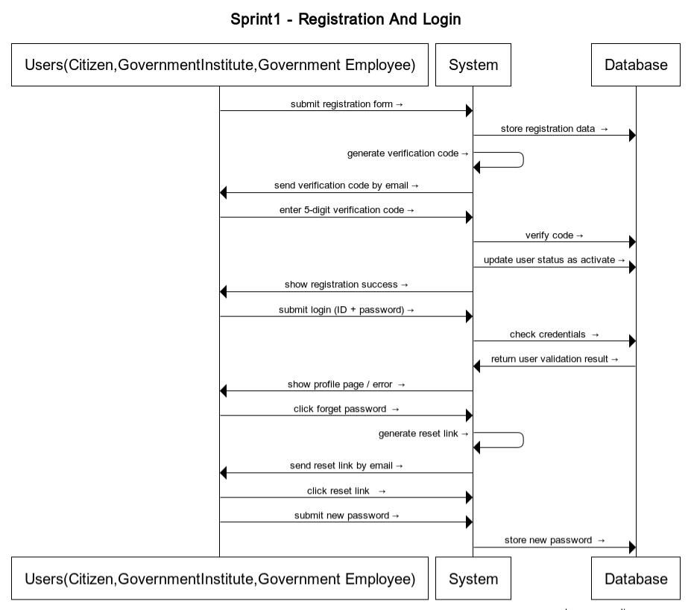

Figure 2: Sequence Digram For Sprint 1

* + 1. **Sprint 2 digrams**

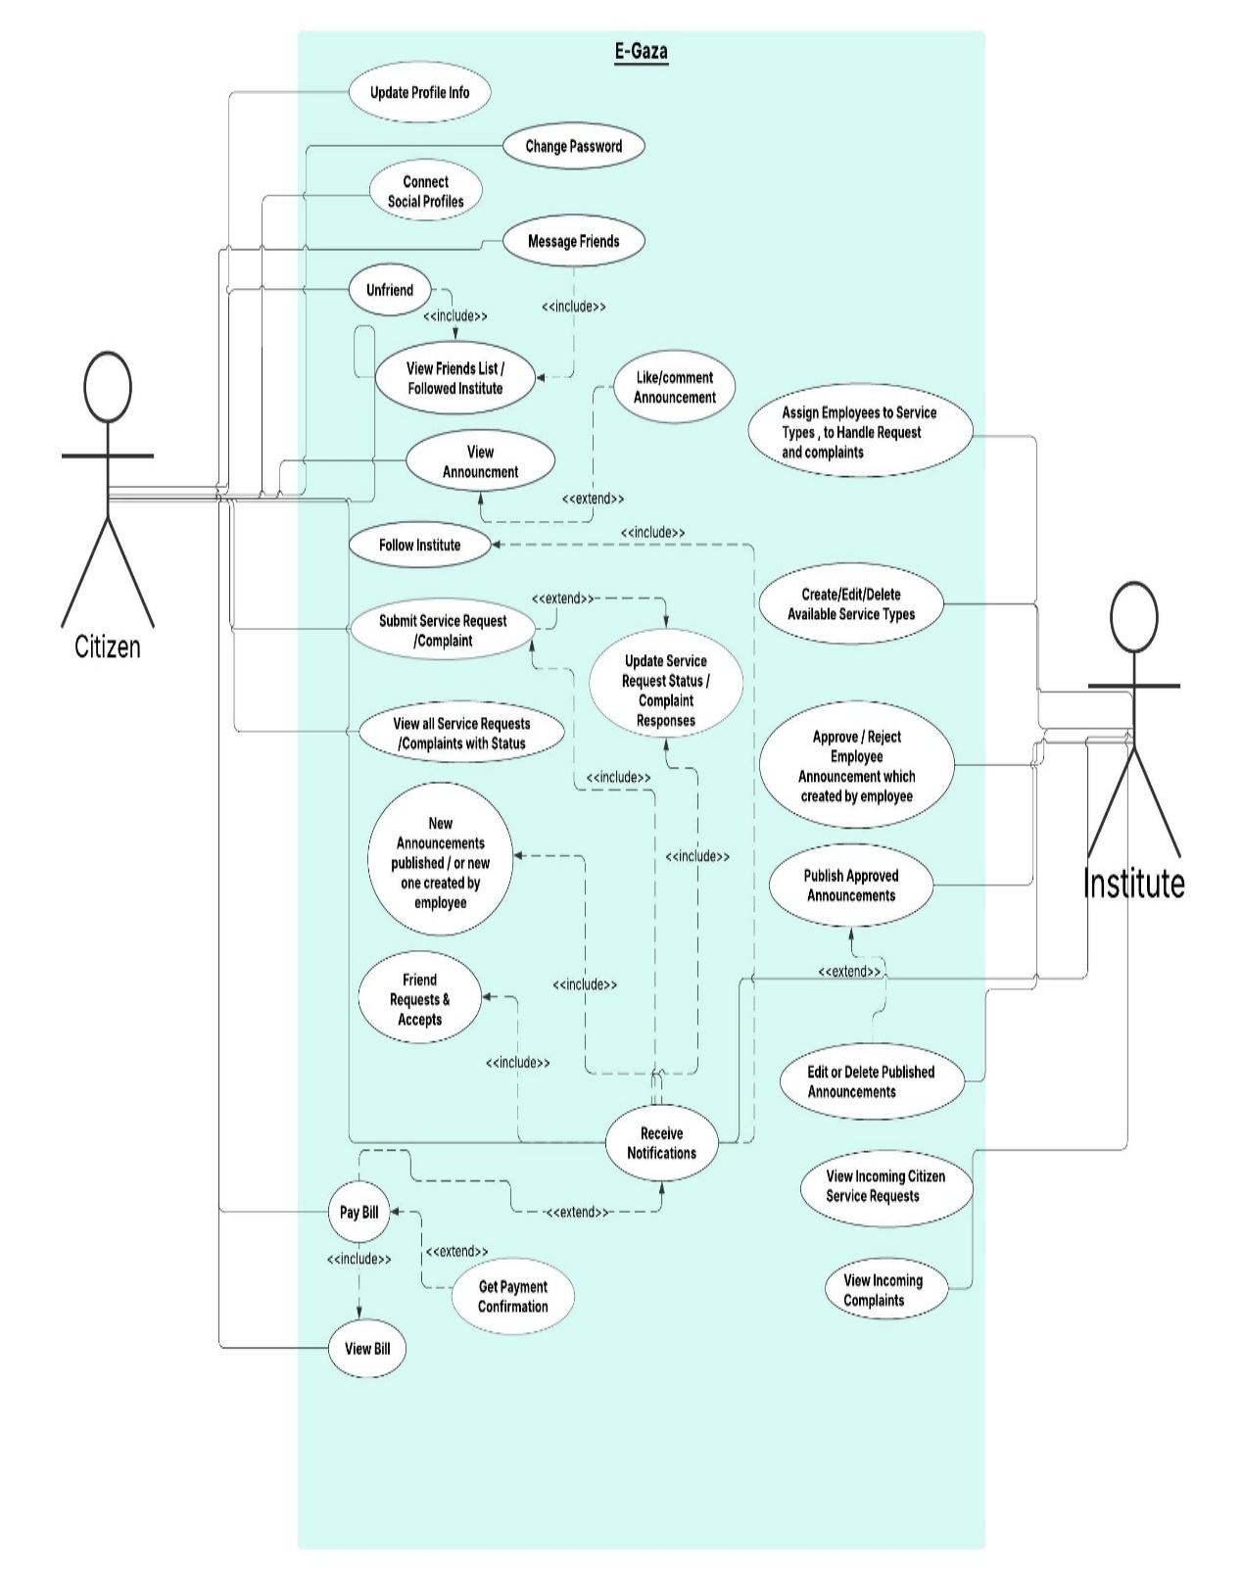

Figure 2: Use Case Digram For Sprint 2

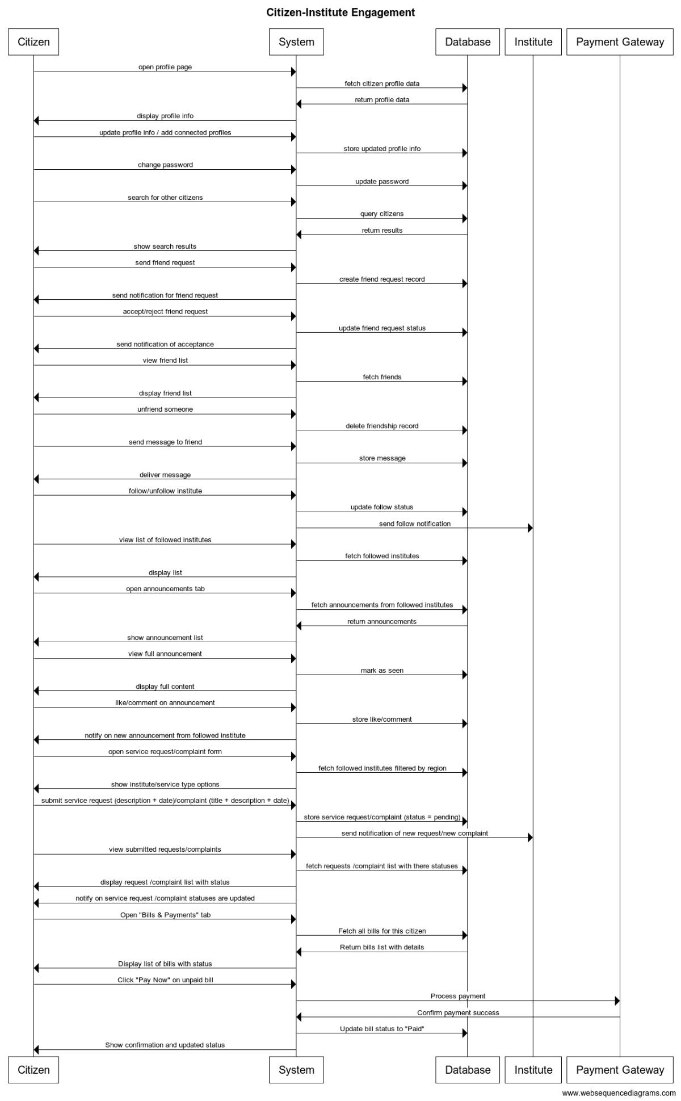

Figure 4: Sequence Digram For Sprint 2

* + 1. **Sprint 3 digrams**

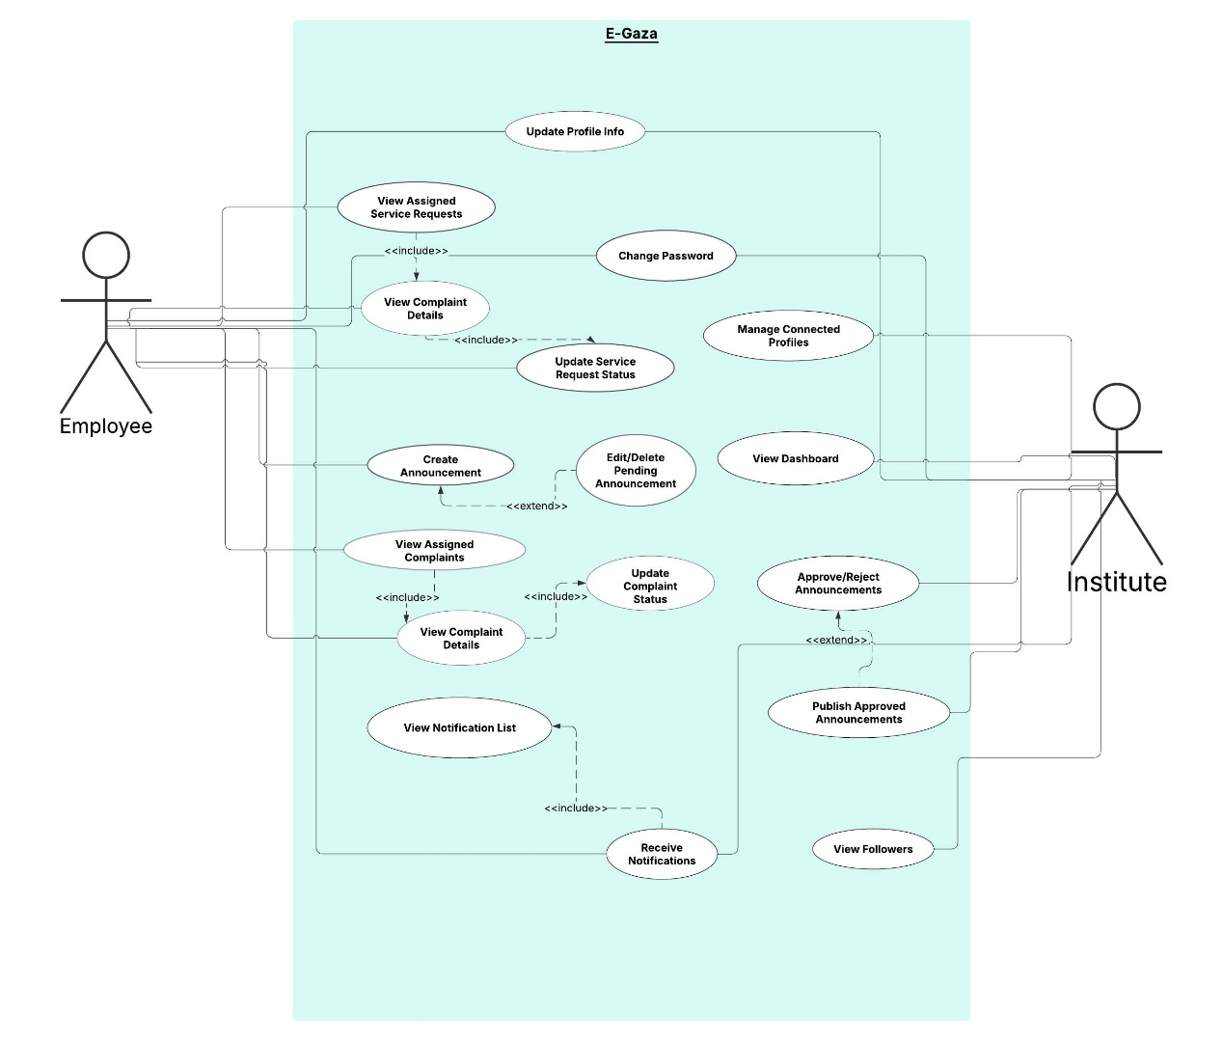

Figure 5: Use Case Digram For Sprint 3

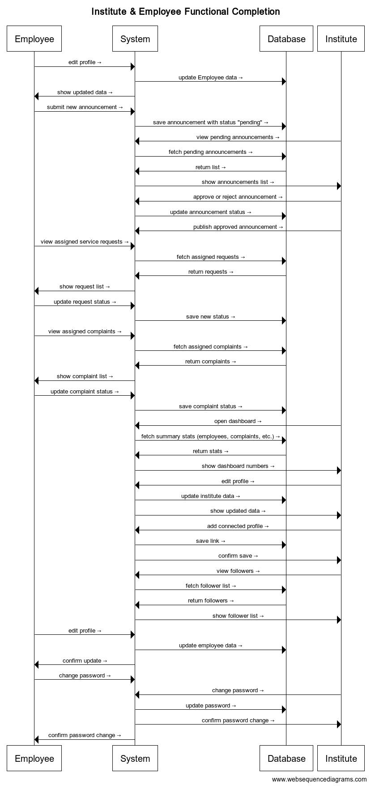

Figure 6: Sequence Digram For Sprint 3

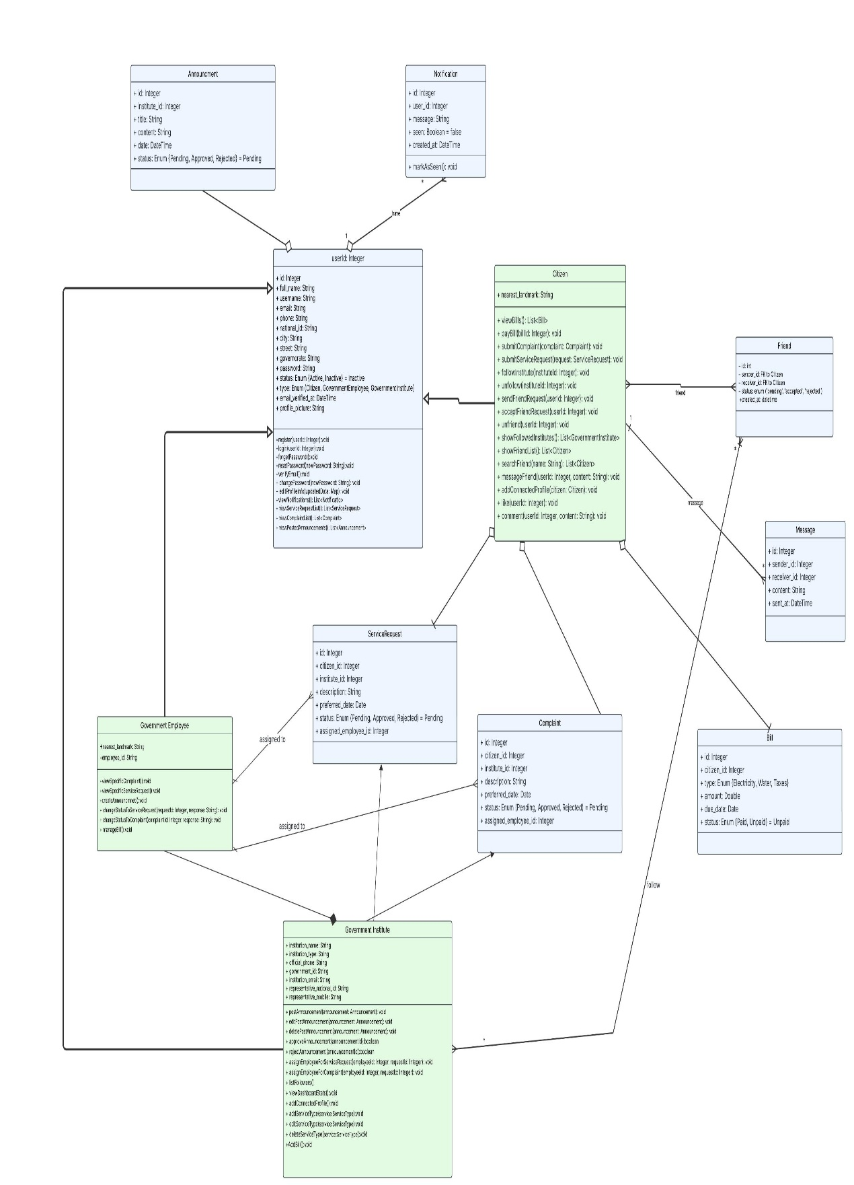

Figure 7: Class Digram For All Sprints

**4.3.4 Sprint 4 digrams**

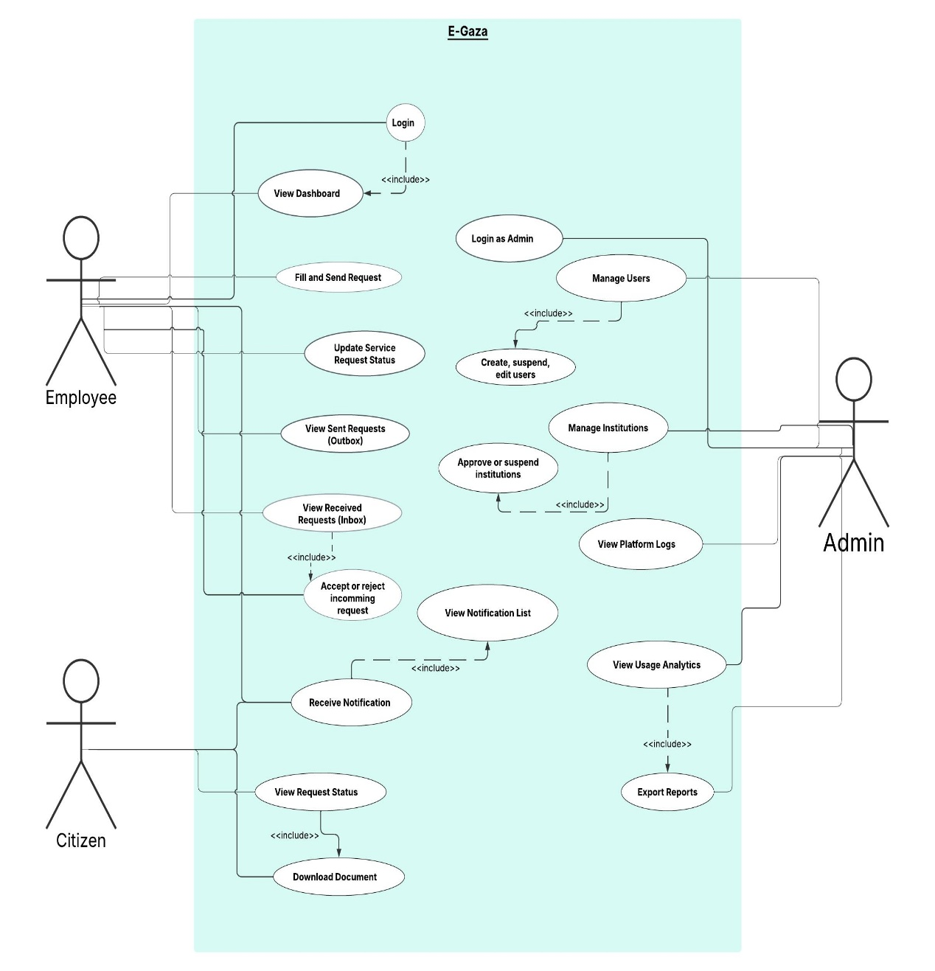

Figure 8: Use Case Digram For Sprint 4

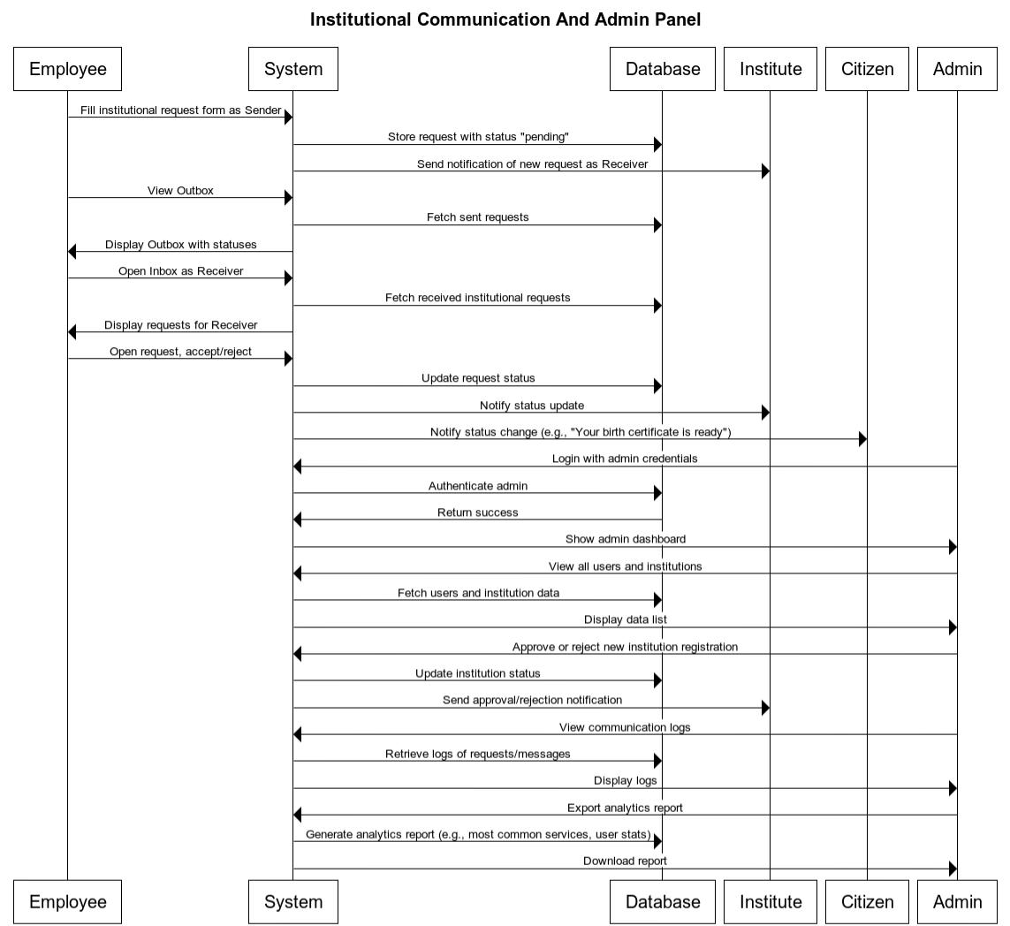

Figure 9: Sequence Digram For Sprint 4

**4.4 Conclusion**

In this chapter, the system’s requirements were thoroughly analyzed and organized according to user roles and development sprints. Sprints 1, 2, and 3 focused on implementing core functionalities such as user registration, login, profile management, dashboard interactions, and communication features .Additionally, Sprint 4 was proposed as a future enhancement to enable institutional communication and provide the admin with full system management capabilities. This sprint aims to improve government workflow efficiency and user experience; however, its implementation is contingent upon the availability of time .The design artifacts included in this chapter will serve as a reference for developers and stakeholders, ensuring consistency, clarity, and alignment with the system’s objectives.